RA_MQTT version 2 UDFBs

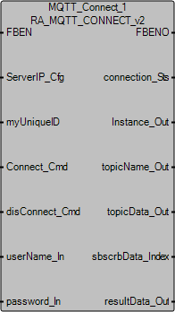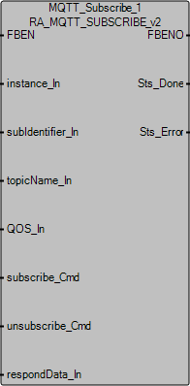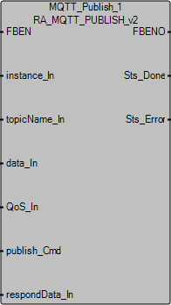
These UDFBs enable a Micro800 controller as MQTT Client to communicate with a MQTT broker/ server in a local or remote server via a non-encrypted connection (typically communicates via port 1883). Users of this application code should evaluate it before actual implementation.
The developer has tested the client application with the following MQTT brokers.
Public broker:
- test.mosquitto.org
- mqtt.eclipse.org
Private broker:
- Cloudmqtt
- Mosquitto
RA_MQTT_CONNECT_v2 UDFB connects a Micro800 to a remote server and receives data for subscribed topics from a remote server.
RA_MQTT_SUBSCRIBE_v2 UDFB subscribes to topics from a remote server.
RA_MQTT_PUBLISH_v2 UDFB publishes topics and data to a remote server.
Note:
Users should use only one instance of each UDFB and keep track of the topics subscribed in their application code or use the optional MQTT_Subscriptions and MQTT_Publications programs to manage arrays of topics.

RA_MQTT_CONNECT_v2 parameters

FB Inputs | Data Type | Description
FBEN | BOOL | Set this to TRUE to enable the UDFB.
ServerIP_Cfg | SOCADDR_CFG | Configure remote MQTT broker/server IPaddress and port number. Typically, non-encrypted port number is 1883.
myUniqueID | STRING | Enter a unique MQTT ID for the Micro800 controller.
Connect_Cmd | BOOL | Upon rising edge trigger, connect to remote server or reset existing connection.
disConnect_Cmd | BOOL | Upon rising edge trigger, disconnect from remote server.
userName_In | STRING | Username and password are optional and subject to remote server. User can leave them blank if username and password are not required to connect to remote MQTT broker/ server.
password_In | STRING
These parameters are set in the UDFB
willTopic_In | STRING | Last Will and Testament (LWT) configuration (optional setting):  Set the Last Will for the connection (optional).
willData_In | STRING | Set the Testament for the connection (optional).
QOS_In | USINT | Quality of service for LWT: 0, 1 or 2 for the will (optional).
keepAlive | DINT | Keep alive interval is preset to 120 seconds within the UDFB.
*In this version of the UDFB, the total number of characters for myUniqueID, username_In, Password_In, willTopic_In and willData_In cannot exceed 245.
FB outputs | Data type | Description
FBENO | BOOL | Function block is active when this is TRUE.
connection_Sts | USINT | Number indicating connection current state.  0 – Initialize  1 – Created  2 – Bind  7 – Connecting  8 – Connecting End  9 – Connected
Instance_Out | UDINT | Instance number for MQTT connection. Need to use this instance number to subscribe and publish topic.
topicName_Out | STRING[1..10] | Topic name and data has been split up into two arrays for convenient data usage.
topicData_Out | STRING[1..10]
sbscrbData_Index | DINT | Denotes the next index incoming data would be assigned to.
resultData_Out | USINT[1..256] | Server respond data is required for publishing data to and subscribing topic from remote server/ broker.

RA_MQTT_SUBSCRIBE_v2 parameters

FB Inputs | Data Type | Description
FBEN | BOOL | Set this to TRUE to enable the UDFB.
instance_In | UDINT | Use the instance number generated from RA_MQTT_CONNECT.
subIdentifier_In | DINT | Enter a unique subscribe ID.
topicName_In | STRING | Enter the topic name to subscribe to.
QOS_In | USINT | Enter the MQTT quality of service required.  - At most once (Default)  - At least once  - Exactly once
subscribe_Cmd | BOOL | Upon rising edge trigger, subscribe to topic.
unsubscribe_Cmd | BOOL | Upon rising edge trigger, unsubscribe from topic.
respondData_In | USINT[1..256] | Input from server respond data.
*In this version of the UDFB, the total number of characters for topicName_In cannot exceed 80.
FB outputs | Data type | Description
FBENO | BOOL | Function block is active when this is TRUE.
Sts_Done | BOOL | Subscribed to topic successfully.
Sts_Error | BOOL | Encountered error when subscribing to topic. Check connection.

RA_MQTT_PUBLISH_v2 parameters

FB Inputs | Data Type | Description
FBEN | BOOL | Set this to TRUE to enable the UDFB.
instance_In | UDINT | Use the instance number generated from RA_MQTT_CONNECT.
topicName_In | STRING | Enter the topic name to publish.
data_In | STRING | Enter the data to be published.
QoS_In | USINT | Enter the MQTT quality of service required.  - At most once (Default)  - At least once  - Exactly once
publish_Cmd | BOOL | Upon rising edge trigger, publish topic with data.
respondData_In | USINT[1..256] | Input from server respond data.
*In this version of the UDFB, the total number of characters for topicName_In and data_In cannot exceed 247.
FB outputs | Data type | Description
FBENO | BOOL | Function block is active when this is TRUE.
Sts_Done | BOOL | Published successfully.
Sts_Error | BOOL | Encountered error when publishing topic. Check connection.

How to connect to or disconnect from a MQTT Broker
A MQTT broker is basically a server to handle MQTT messages. To connect to an MQTT broker, we need to assign the broker IP address and port number into RA_MQTT_CONNECT_v2 UDFB. The broker can reside in your computer (in which you need to install and run a MQTT broker for your OS) or it can be remote server such as the ones listed above.
- Assign the IP address and port number of the MQTT broker to your RA_MQTT_CONNECT_v2 UDFB.
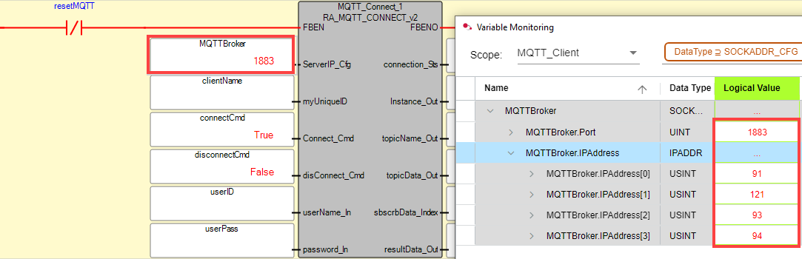
In this example, I am connecting to the test.mosquitto.org broker in the cloud. An alternative to entering the IP address directly is to enable Domain Name Service (set ‘EnableDNS’ TRUE) after entering in the MQTT broker URL into ‘MQTTBrokerName’ and the local DNS server IP address into ‘DNSIPaddr’ in rung 2.
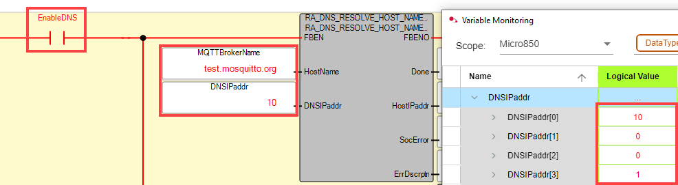

- Enter a unique ‘clientName’, as well as a ‘userID’ and ‘userPass’ if your MQTT broker requires it. (Many public MQTT brokers do not require a username and password, so these fields are optional and can be left blank if not required.)
- Set ‘EnableMQTT’ to TRUE to connect to the MQTT broker.
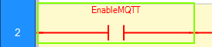
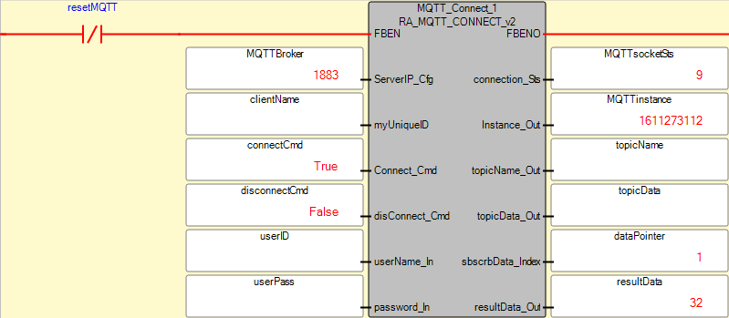
Note:
A few things to note for a successful connection. The MQTTsocketSts should show 9 eventually. If it shows 7 and then goes back to 0, it could mean that your broker is not running or does not exist.
The data in resultData_Out is good for diagnostic troubleshooting. Typically, when you send a connect command to the server, the server will send an acknowledgement back. The acknowledgement is denoted by the 1st byte and in this case, it is ‘32’.
Another common response you will get is a ping acknowledgement. This is denoted by ‘208’ in the 1st byte of return data. The ping command is sent to the remote broker at a 50 second interval. This is hardcoded in the UDFB but can be edited if necessary.
If the return data is something other than 32 or 208 upon connect, it could mean that the client has subscribed to a topic that was transmitted while it was offline. The message is being retained and sent to the client when it is online. If you encounter this, reinitialize the connection again after processing that message.

- If you want to configure for LWT, you need to access these parameters in the UDFB:
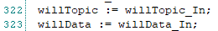
‘willTopic_In’ is where you enter the Last Will topic for the connection.
‘willData_In’ is where you enter the testament for the connection.
The MQTT broker will publish the testament to all clients that subscribe to the Last Will topic when the client is disconnected abruptly.
- If you want to disconnect gracefully from the server (without triggering LWT), set ‘disconnect_Cmd’ to TRUE.
This is a rising edge triggered bit, so you can reset it immediately.

How to manually subscribe to or unsubscribe from a topic
MQTT protocol exchanges data via subscribe and publish methods. Clients only directly communicate with the MQTT broker. Clients that subscribe to a topic will receive a message from the broker when another client publishes to that topic. Clients can be in any form as long as they have a MQTT client application running. For example, it can be software in a PC, a connector or API for the software, an app in a phone or application code in a PLC.
- Enter the name of the topic (‘topicName_input’) to subscribe to or unsubscribe from.
- Set the quality of service (‘subQoS’) for the subscription. By default, use ‘0’ as it consumes the least bandwidth.
- Set ‘subscribe’ or ‘unsubscribe’ to TRUE to subscribe to or unsubscribe from the topic.
These bits detect for rising edge, so you can reset them immediately.
- Notice that the resultData_Out from RA_MQTT_CONNECT_v2 is also copied to respondData_In.
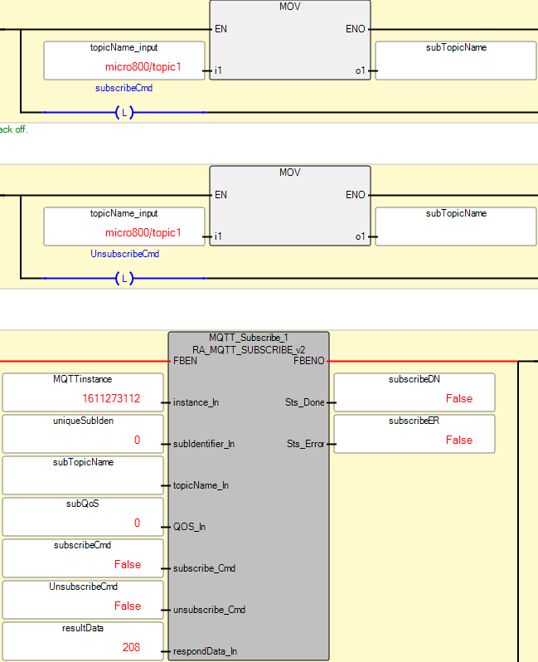
Note:
It is recommended to use only 1 instance of each UDFB.

How to manually publish a topic
When a topic is published with data to a MQTT broker, the broker then forwards this topic data to all the clients that subscribe to it. The client that publishes the message does not know if any remote nodes receive the topic as that is the responsibility of the broker, based on the QOS level. Topics can be published or subscribed to at whichever QO,S but it will only be delivered at the lowest QOS level.
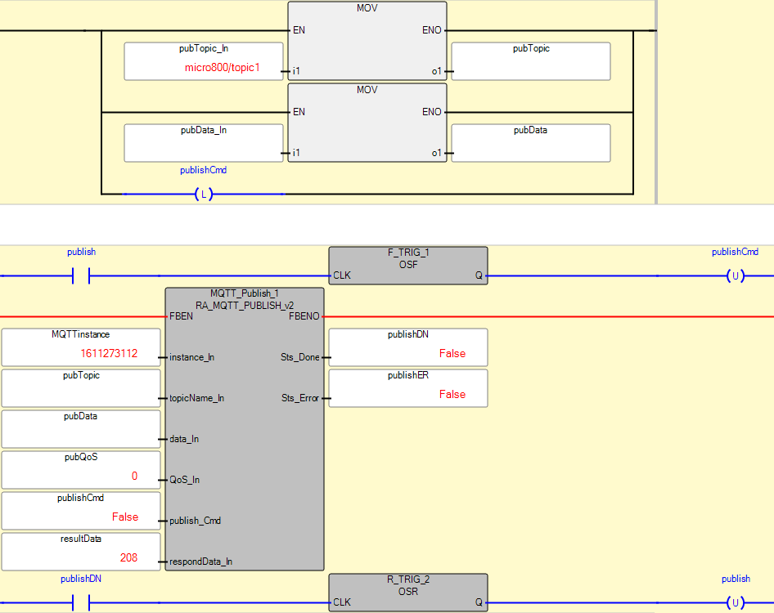
- Enter the topic to publish into ‘pubTopic_In’.
- Enter the data for the topic into ‘pubData_In’.
- Set the quality of service into ‘pubQoS’. By default, use ‘0’ as it consumes the least bandwidth.
- Set ‘publish’ to TRUE to publish the topic with its data. It will automatically will be set back to FALSE when ‘publishDN’ becomes TRUE.
- Notice that the resultData_Out from RA_MQTT_CONNECT_v2 is also copied to respondData_In.

Incoming messages from subscribed topics
The MQTT broker takes care of all topic subscriptions. It will send the data of any topic published to the clients that subscribe to it. When a topic is received by the Micro800 MQTT client, it gets populated in the RA_MQTT_CONNECT_v2 UDFB to array variables ‘TopicName’ and ‘TopicData’. Data is being stored in a First In/First Out order, so be sure to process the data before it gets overwritten.
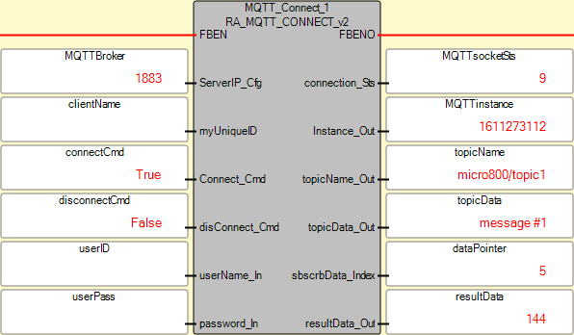

How to automatically subscribe to an array of topics
MQTT_Subscriptions is an optional structured text program that works together with the MQTT_Client program. It allows you to subscribe to an entire 'Subscriptions' array of preconfigured topics. Set the array dimension of global variable 'Subscriptions' to the desired size and change the initial value of local variable 'maxSubscriptions' to match size of the array (default=10). 'Subscriptions' is a User-defined Data Type (UDT) array consisting of the MQTT topic 'Name', the latest topic 'Data', a timestamp based on the RTC value when the latest topic 'Data' was received and a 'Subscribed' indicator. Enter in the desired topic names to subscribe to as initial values for Subscriptions[i].Name before downloading the project to the controller.
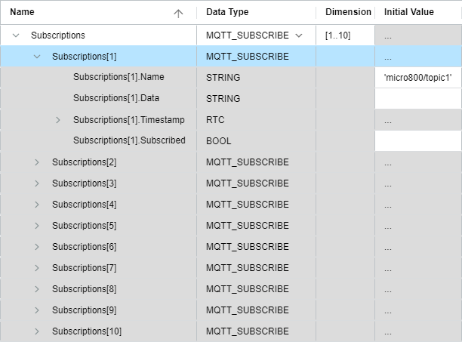
Local variable 'enableSubcriptions' must be TRUE in order to enable this functionality.
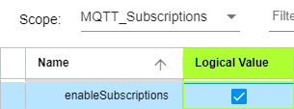
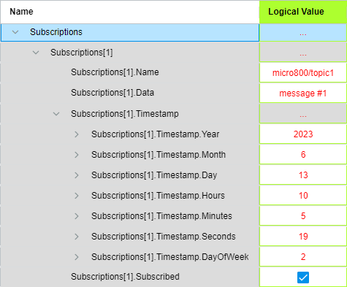

How to automatically publish an array of topics
MQTT_Publications is an optional structured text program that works together with the MQTT_Client program. It allows you to publish an entire 'Publications' array of preconfigured topics. Set the array dimension of global variable 'Publications' to the desired size and change the initial value of local variable 'maxPublications' to match size of the array (default=10). 'Publications' is a User-defined Data Type (UDT) array consisting of the MQTT topic 'Name', the latest topic 'Value', the previous topic value 'Valueprev' and a timestamp based on the RTC value when the latest topic 'Value' was published. Enter in the desired topic names to publish as initial values for Publications[i].Name before downloading the project to the controller.
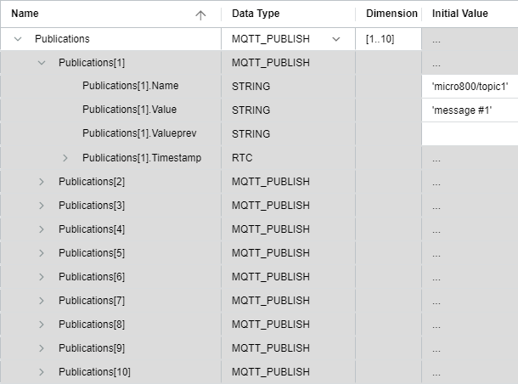
Set local variable 'ChangeOfState' to TRUE in order to publish any value that changes on an exception basis. Set local variable 'Interval' to TRUE and 'intervalTime' to a non-zero-time value in order to publish all of the current values that aren't null ('') on a timed interval basis. Normally, one will choose either 'ChangeOfState' or 'Interval' as the method for publishing topic updates. For a one-time update, set local variable 'OnDemand' to TRUE in order to publish all of the current values that aren't null (''). 'OnDemand' is set to FALSE once the entire 'Publications' array has been published. Local variable 'enablePublications' must be TRUE in order to enable this program functionality.
